Information sheet for DFG Own Position (Eigene Stelle) at AWI

The DFG “Own position” (“Eigene Stelle”) is the standard programme for postdocs who want to apply for their own position.

This is a DFG Research Grant (Sachbeihilfe) including the modules Basic Module (for all the other costs of your project) and the Module Temporary Positions for Principal Investigators (for your own position).
https://www.dfg.de/en/research_funding/programmes/individual/research_grants/index.html
With such a grant, you can get funding for up to 3 years.
Applications are possible at any time.
There is no upper limit for the funding – the budget needs to fit the planned work.
But as a strategic consideration it would be wise not to have a too large project:
smaller projects might get funded, where larger projects may not due to DFG budget constraints.
If you apply for your own position, we therefore recommend not to add other personnel, or at the most maybe a student assistant.

Important: if you want to apply with AWI (a Helmholtz Centre) as the host institution for your own position, the DFG´s Duty to cooperate applies!
http://www.dfg.de/formulare/55_01/55_01_en.pdf

=> If you want to apply for your own position at AWI, you need a co-PI from a German university who gets more than 50% of the total funding.
This means that you and your co-PI would be both applicants. It would be a joint project in which you work together.

It does not matter for what kind of costs the co-PI applies, as long as they get more than 50%.
But on your side, there will be your postdoc salary plus your travel, consumables, publications etc.
Since personnel is usually the most expensive cost category, it is very likely that the co-PI will also apply for positions (for example, the co-PI could also be postdoc applying for their own position, or it could be someone who does not need funding for their own position applying for PhD position(s)).

As a consequence, the whole project needs to be bigger, because the planned work must be enough to justify the personnel on both sides working for the project.

Note that the duty to cooperate also applies in those calls for international cooperation projects that the DFG sometimes publishes together with other funding organisations (e.g. the DFG-ANR calls for German-French projects, or the AEI-DFG call for Spanish-German projects). In those calls, you usually find that the eligibility rules for the DFG research grants apply, including the duty to cooperate. This means that in addition to the international partner, you also need a partner from a German university who gets more than 50% of the funding on the German side:

“Please note that the rules for funding eligibility apply to all applicants from Germany, including the duty to cooperate for non-university researchers. Any duty to cooperate for DFG applicants at non-university research institutions can only be fulfilled through cooperation with a partner at a German university”

There are several exceptions from the duty to cooperate:

- If you are less than 6 years after PhD and AWI is willing to co-finance 45% of your project, you can apply on your own (in this case, AWI "buys you out of the duty to cooperate").
In order to benefit from this exception, you need to contact the section in which you want to be affiliated and ask them if they are willing to co-fund you.

- If you apply for your own position within a Priority Programme (Schwerpunktprogramm – SPP), the duty to cooperate does not apply. i.e. you can apply on your own.

> List of ongoing SPPs: https://gepris.dfg.de/gepris/programmlisten?language=en#PROGRAMM=Priority%20Programmes
> Calls for proposals within SPPs are published here: https://www.dfg.de/en/research_funding/announcements_proposals/index.jsp

Note that most SPPs run for 6 years and publish 2 calls for 3-year funding periods during this time. This means that SPPs that are already in their 4th-6th year will not publish another call.

- Special case: SPP 1158 Antarctic Research

If your research topic is related to Antarctica, you can apply within this SPP 1158.

This SPP is ongoing (with a review of the programme every 6 years) and publishes a call once per year, with a deadline at the beginning of November.
If you want to apply, you must present your planned proposal at the annual workshop in September.
https://www.spp-antarktisforschung.uni-rostock.de/en/organisation/application-process/general/

As in all SPPs, the duty to cooperate does not apply, i.e. you are allowed to apply on your own for your own position at AWI.
But you need to know that they do not like to fund too many positions at AWI within the SPP 1158.
(The reason is the political background: the SPP exists in order to open up AWI´s infrastructure to other polar researchers in Germany. If too much SPP funding goes to AWI, the DFG might decide not to continue the SPP.)
AWI applicants have been too successful in the past, therefore the SPP leaders are now rather wary. Some applicants are successful nonetheless, but it is still much easier to get an own position funded via the SPP if your host institution is a university.

Note that the SPP´s budget is limited and that they strongly advise to apply only for 2 years of postdoc positions, instead of the usual 3 years.

- The duty to cooperate does not apply in the Walter Benjamin programme, the Emmy Noether programme, the Heisenberg programme and within several other programmes (see http://www.dfg.de/formulare/55_01/55_01_en.pdf p. 2).

So, to recap, there are 4 possibilities to apply for your Own Position within a Research Grant:

- Own position at AWI, with a co-PI from a German university
- Own position at AWI, without a co-PI – if the applicant is < 6 years after PhD and AWI funds 45% of the costs
- Own position at AWI, without a co-PI – funded via an SPP
- Own position at a university – if you leave the AWI and choose a university as the host institution instead, there is no duty to cooperate!, therefore no need for a co-PI.

In scenario no. 4, you can still cooperate with AWI researchers: you can travel / have research stays at AWI, invite AWI colleagues as guests, or include them as a more intensive cooperation partner (see Module Mercator Fellows https://www.dfg.de/formulare/52_05/index.jsp).
But the main part of your activity must be at the university: if you just get the work contract from the university, but in reality spend all your time at AWI, this will look like you want to circumvent the duty to cooperate, and the DFG will not like that.

All forms and guidelines for the Research Grant programme are listed here:
https://www.dfg.de/foerderung/programme/einzelfoerderung/sachbeihilfe/formulare_merkblaetter/index.jsp
You will need in particular:

  - 50.01 – Guidelines Research Grants Programme https://www.dfg.de/formulare/50_01/50_01_en.pdf
  - 52.01 – Module Basic Module https://www.dfg.de/formulare/52_01/52_01_en.pdf
  - 52.02 – Module Temporary Positions for Principal Investigators https://www.dfg.de/formulare/52_02/52_02_en.pdf

  - 54.01 – Proposal Preparation Instructions https://www.dfg.de/formulare/54_01/54_01_en.pdf
  - 53.01 – Project Description – Project Proposal https://www.dfg.de/formulare/53_01_elan/53_01_en_elan.rtf -
this is the template for the proposal text!
  - 53.200 – Curriculum Vitae https://www.dfg.de/formulare/53_200_elan/53_200_en_elan.rtf
  - 1.91 – Guidelines for Preparing Publication lists https://www.dfg.de/formulare/1_91/1_91_en.pdf

  - 41.027 – Arbeitgebererklärung (host declaration, to be signed by AWI directors / the host university) https://www.dfg.de/formulare/41_027/41_027_de_rtf.rtf

You also need to register in the DFG online application system elan: https://elan.dfg.de/my.policy

If you decide to apply with AWI as the host institution, you should get in contact with the head of the section to which you want to be affiliated (if you have not done this yet).
They need to support your application and also help you with the AWI-internal "Laufzettel" procedure (the Laufzettel needs to be signed by the section head, the Grants Management, the head of Research Support, and the directors before you can apply).

Our colleagues at the Pre-Award team (pre-award@awi.de) will support you regarding the budget planning, the AWI-internal Laufzettel procedure, and the signature for the host declaration
(see DFG form 41.027 https://www.dfg.de/formulare/41_027/41_027_de_rtf.rtf).

The funding advice team (Imke.Fries@awi.de) will support you with all other aspects of the proposal.
Note that we may not be able to give feedback on the proposal draft, this depends on how much other urgent proposals we have to support at the same time.

If you apply with a university as the host institution, please contact their team in charge of third party funding to find out about the university´s internal procedures.

For further information, check also the DFG´s FAQ for “Eigene Stelle”: https://www.dfg.de/en/research_funding/faq/faq_temporary_positions/index.html

Additional information we got from the DFG:

It is possible to spend time abroad during your Research Grant / own position, e.g. for a research stay or to visit other researchers. The time abroad should not be more than 1/3 of the duration of the grant, e.g. not more than 1 year in a 3-year project.
You can apply for the funds in the section “travel costs”. For longer stays, please do not use hotels and daily allowance rates, but look for a less expensive option (e.g. a guest house run by the institution you want to visit).

Duty to Cooperate – overview

Programme | Remarks | Duty to Cooperate
Research Grant (Sachbeihilfe)  incl. Own Position | Standard case | YES
 | PhD < 6 years, AND  AWI co-finances 45% of the budget |  | NO
 | University as host institution  (= not at AWI) |  | NO
Research Grant incl. Own Position within a binational call,  e.g. DFG-ANR | Same rules as above!  - If the duty to cooperate applies, you need a co-PI from a German university in addition to the international partner.
Research Grant incl. Own Position  within a normal SPP  (Schwerpunktprogramm / Priority Programme) |  |  | NO
Research Grant incl. Own Position  within the  SPP 1158 Antarctic Research | SPP recommends to apply only for 2 years, not 3  (due to budget restraints) |  | NO

Background:

The DFG primarily wants to fund universities, not research institutes.
Reason: Helmholtz Association / Max Planck Society / Fraunhofer Association get more funding from the federal government than universities.

How it works:

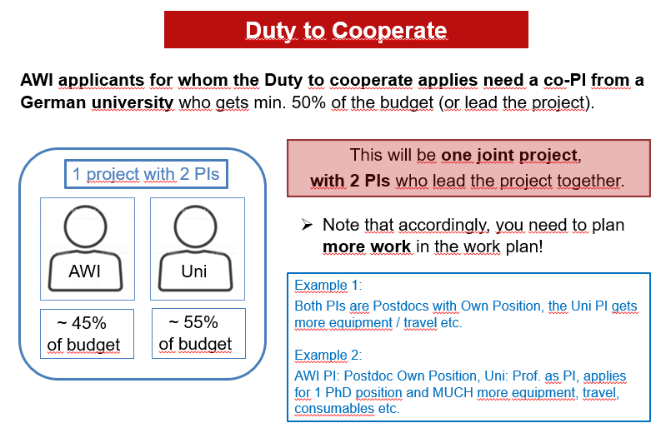

Recommendation: Make sure that the university partner gets a little bit more than 50% of the total budget – e.g. make it 55% – so that there is a buffer in case the DFG cuts some costs at the university´s part of the budget.

